**Geometric Wood Wall Art Set**

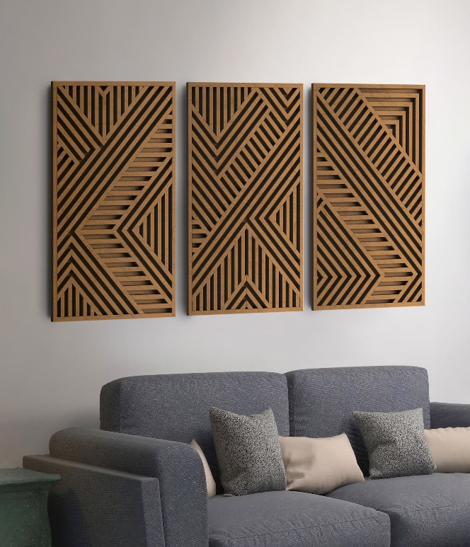Geometric wood wall art sets are a stunning blend of craftsmanship and design, perfect for elevating any interior space. These art pieces often feature intricate patterns, such as chevrons, triangles, or abstract geometric designs, crafted from natural wood in varying tones and textures. The combination of precision cuts and the organic warmth of wood creates a striking contrast, making them both modern and timeless. Ideal for living rooms, bedrooms, or offices, these wall art sets can be arranged in different layouts to suit personal style and space. Their handcrafted nature ensures each piece is unique, adding character and depth to your decor.